SWITCH WINDOW

https://www.browserstack.com/guide/handle-multiple-windows-in-selenium#:~:text=Get%20the%20handles%20of%20all%20the%20windows%20that%20are%20currently,URL%20of%20the%20web%20page.
Switch Frames

iFrame in Selenium Webdriver
iFrame in Selenium Webdriver is a web page or an inline frame which is embedded in another web page or an HTML document embedded inside another HTML document. The iframe is often used to add content from other sources like an advertisement into a web page. The iframe is defined with the <iframe> tag.

Table of Content:
- iFrame in Selenium Webdriver
- How to identify the iFrame
- How to Handle Frames in Selenium using WebDriver Commands
  - Method 1: Switch to the frame by index
  - Method 2: Switch to the frame by Name or ID
  - Method 3: Switch to the frame by Web Element
- Concept of Nested Frames in Selenium:

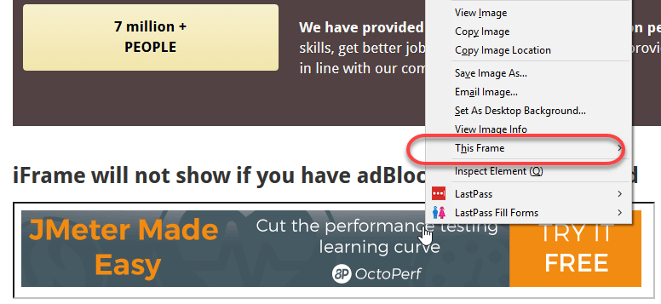

We can identify the frames in Selenium using methods given below:
- Right click on the element, If you find the option like ‘This Frame’ then it is an iframe.(Please refer the above diagram)
- Right click on the page and click ‘View Page Source’ and Search with the ‘iframe’, if you can find any tag name with the ‘iframe’ then it is meaning to say the page consisting an iframe.
In above diagram, you can see that ‘This Frame‘ option is available upon right clicking, so we are now sure that it is an iframe.
We can even identify total number of iframes by using below snippet.
Int size = driver.findElements(By.tagName("iframe")).size();

How to Handle Frames in Selenium using WebDriver Commands
Basically, we can switch over the elements and handle frames in Selenium using 3 ways.
- By Index
- By Name or Id
- By Web Element

Method 1: Switch to the frame by index
Index is one of the attributes for frame handling in Selenium through which we can switch to it.
Index of the iframe starts with ‘0’.
Suppose if there are 100 frames in page, we can switch to frame in Selenium by using index.
- driver.switchTo().frame(0);
- driver.switchTo().frame(1);

Method 2: Switch to the frame by Name or ID
Name and ID are attributes for handling frames in Selenium through which we can switch to the iframe.
- driver.switchTo().frame("iframe1");
- driver.switchTo().frame("id of the element");

https://www.guru99.com/handling-iframes-selenium.html

